**Creation of virtual machine**

Click on start lab and Open Cloud shell console window.

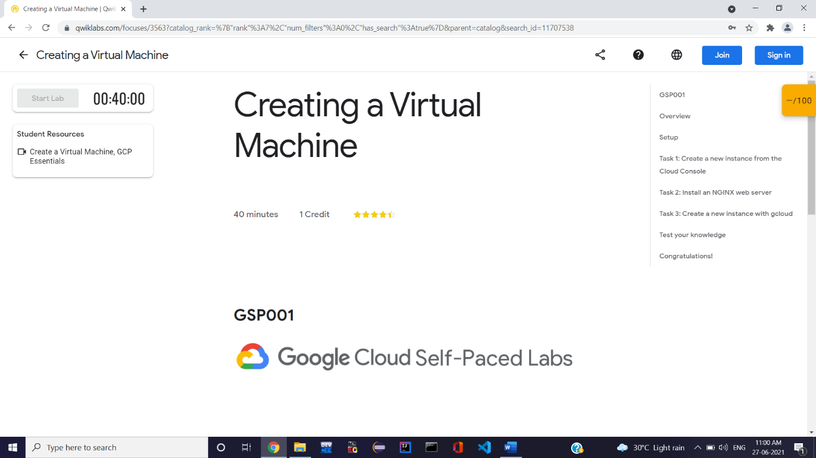

To list the active account name use the command- **gcloud auth list**

Output-

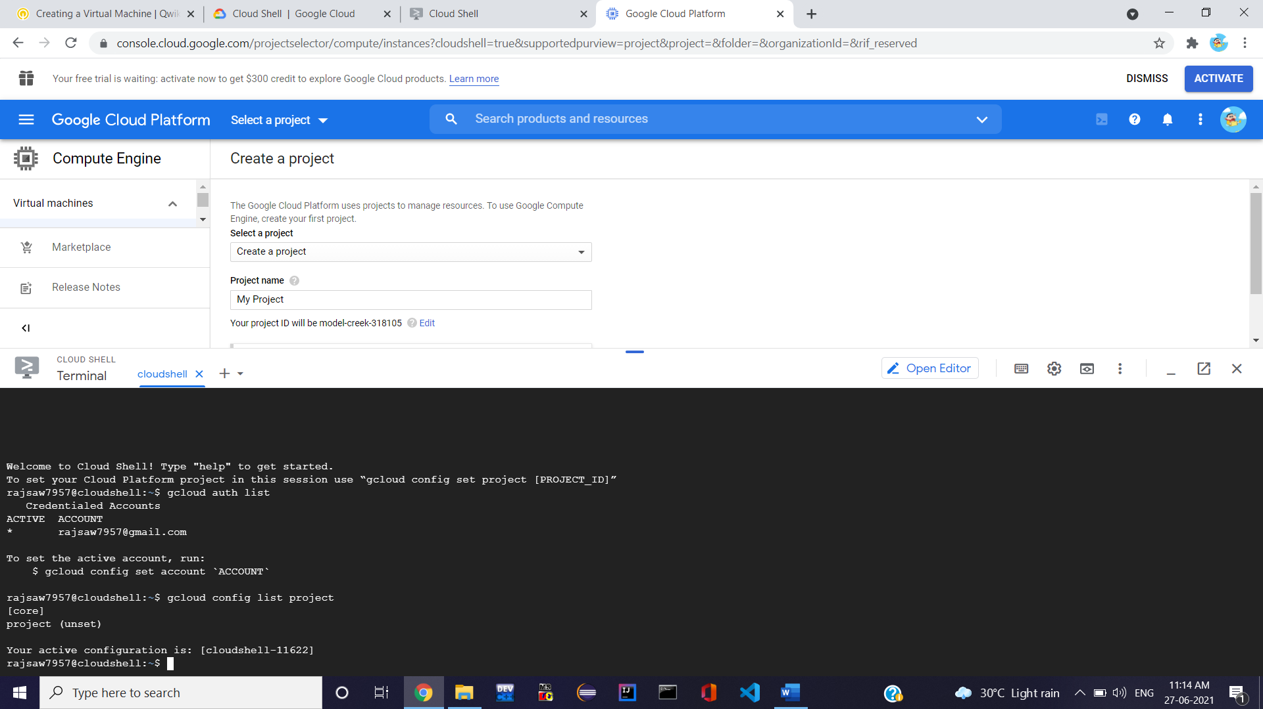

Output-



**Create a new instance from the Cloud Console**

Click on **Navigation menu ->** **Compute Engine -** > **VM Instances and click on create instance. Click on SSH to connect to the virtual machine.**



**Install NGINX web server**

To get the root access use the command- **sudo su**

Update the OS- **apt-get update**

Output-

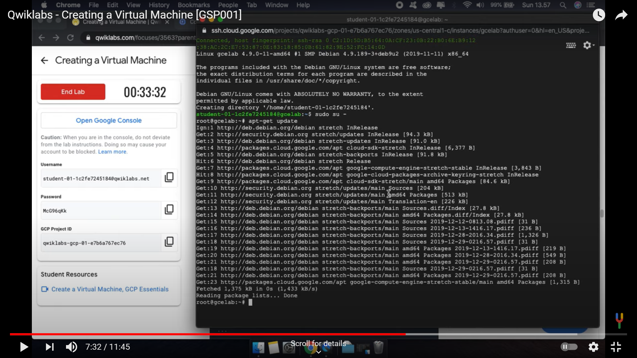

Install NGINX- **apt-get install nginx -y**

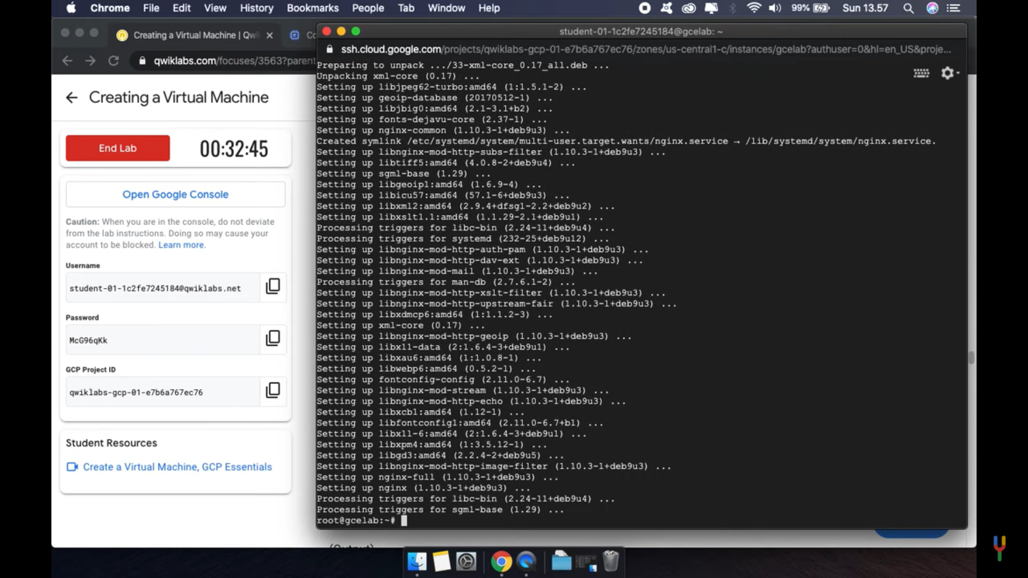

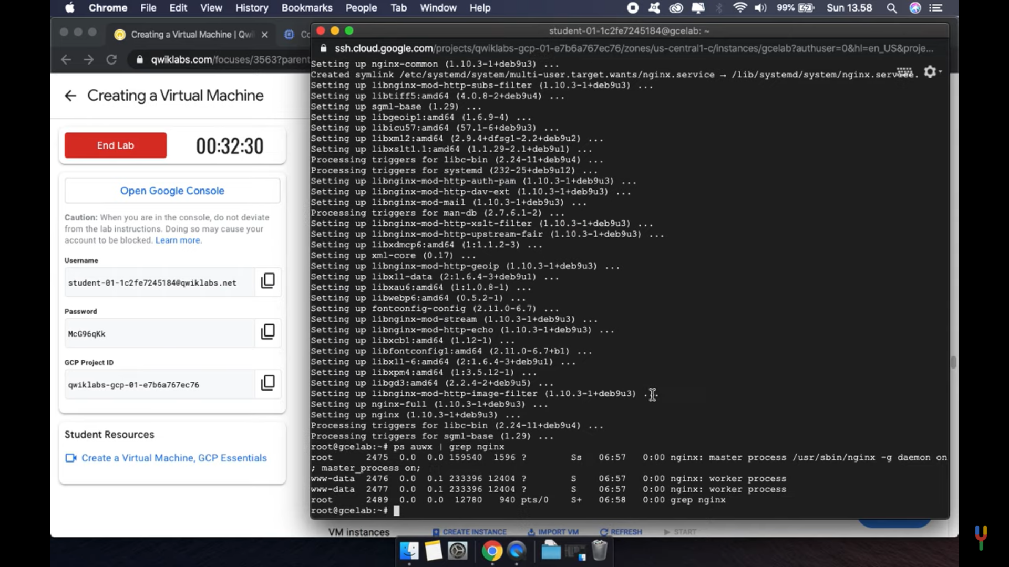

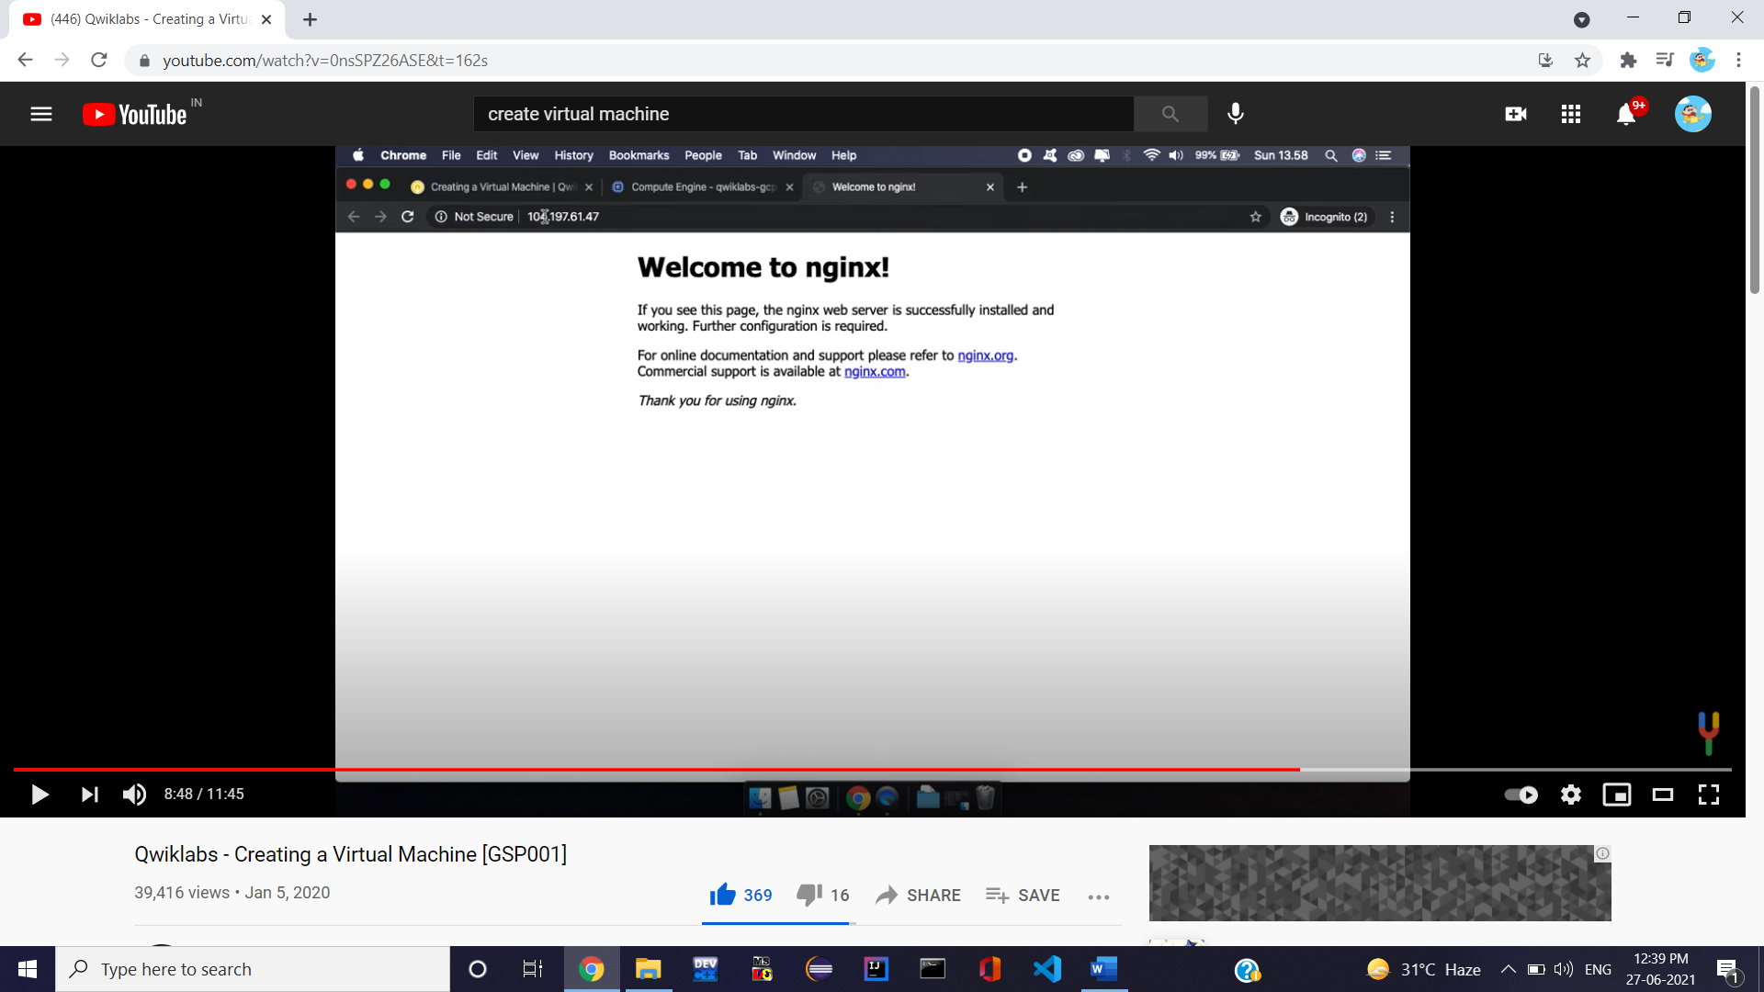

After connecting or disconnecting from SSH use command **exit.**